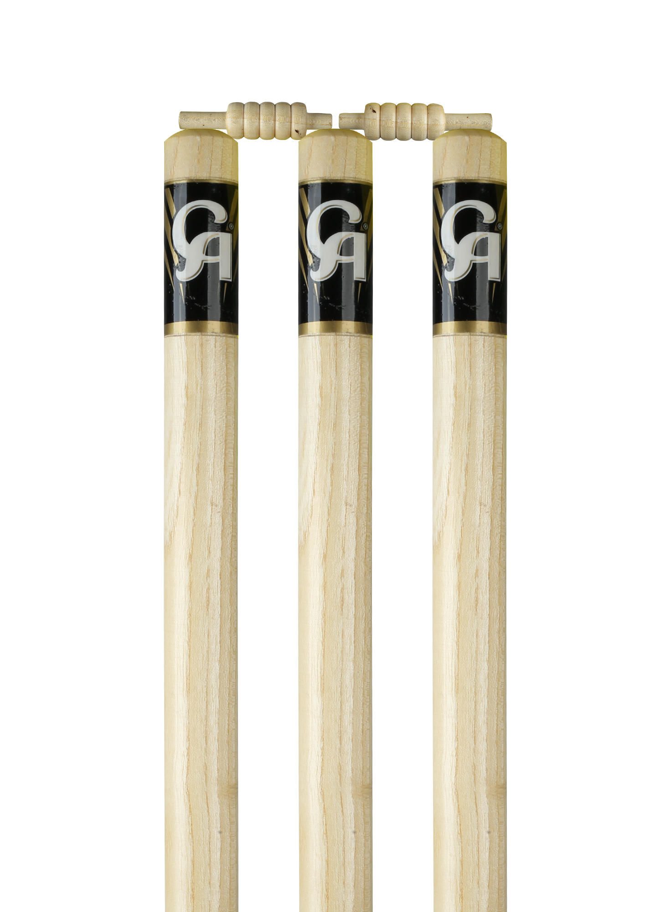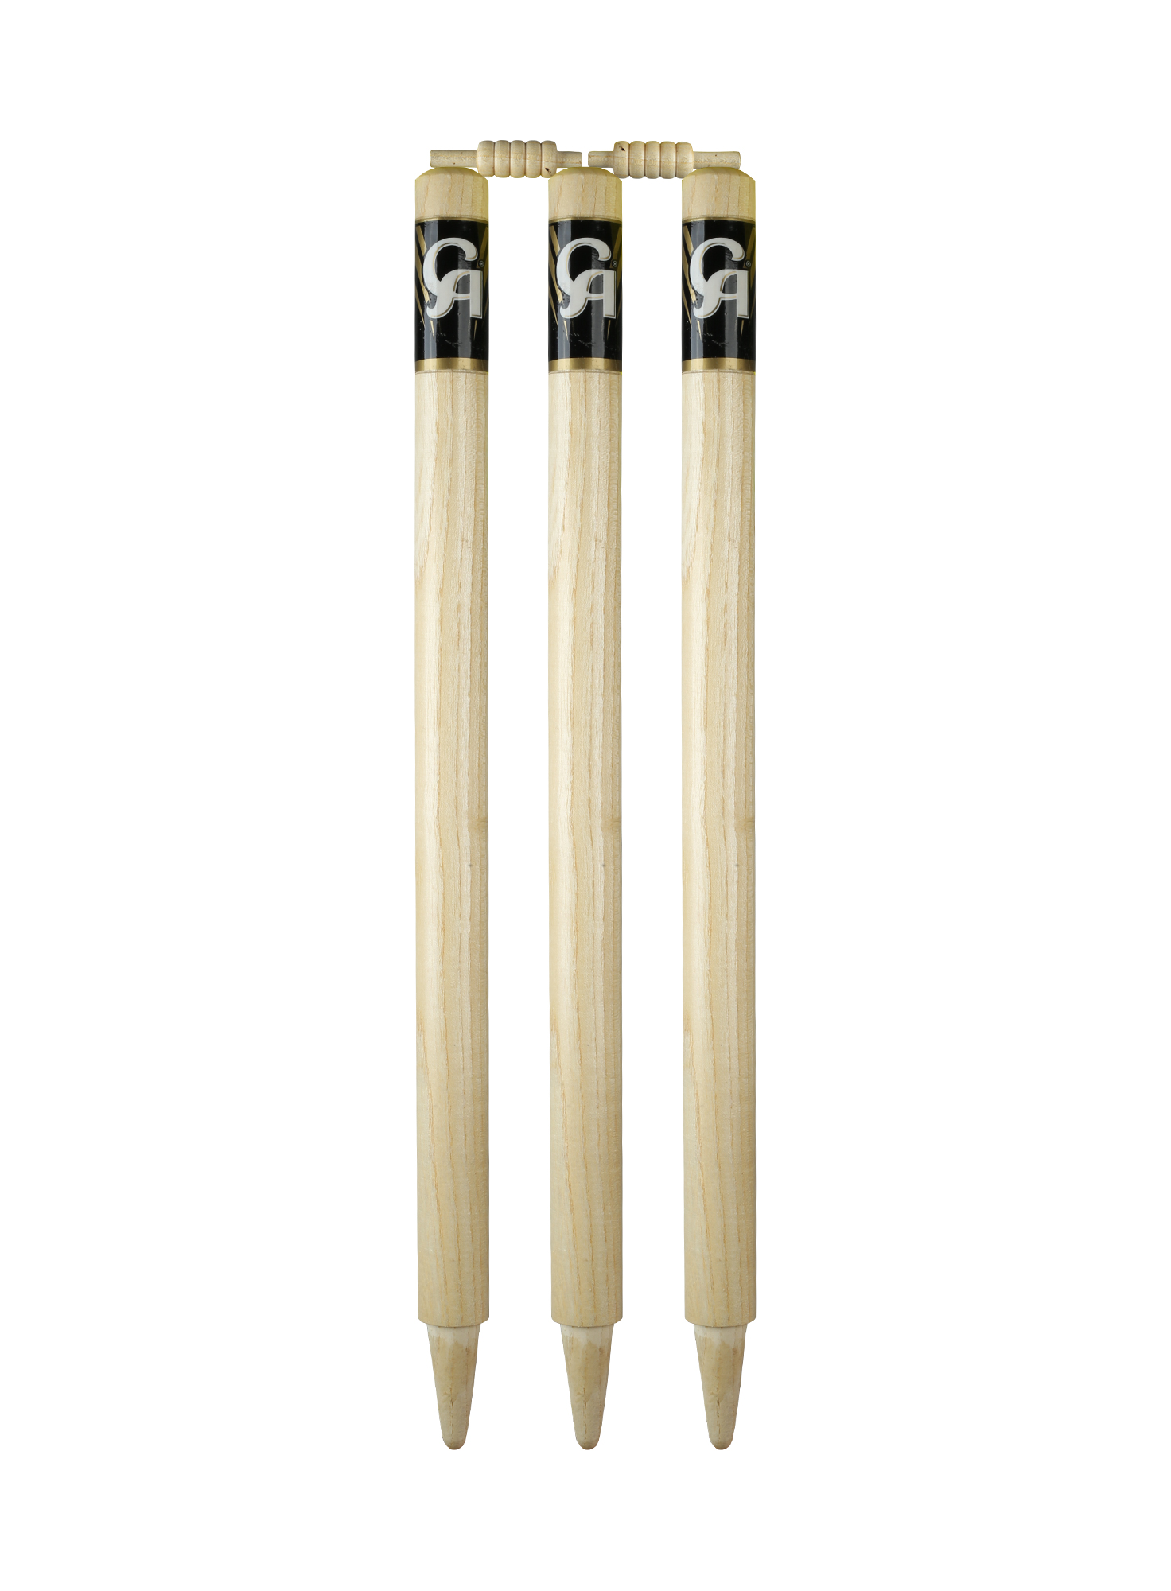

CA SPORTS WICKET

The famous CA Stumps are quality products for serious cricketers who love to play on the ground and grass wickets. Strong Ashwood stumps and the set of bails liquored in shiny protector makes it a perfect product for outdoor cricket.

DETAILS:

* Made of assorted Ashwood
* Comes with a pair of bails
* Strong enough for the fast bowlers
* Labeled with the CA Sticker
* Light in weight